**Bisrat Asefaw**

**CSS 478 A (User-Centered Design)**

**Professor Annuska**

**Initial Affective Technology Immersion**

**Target audience:**

Our target audience is everyone who uses text messaging. Our users may want to use our technology in order to reduce misinterpretations which are common in texting. Oftentimes, misunderstanding can occur between two parties. We believe our technology will eliminate these issues and lead to effective communication. Our users can be characterized for research purposes in three categories; age, gender and cultural background.

**Main goals:**

To help achieve our main goals of our technology, we can generate a series of questions and scenarios. In short, the main goal of our technology are:

1. Increase acceptability and improve the usability of our technology
2. Improve efficiency of communication by incorporating a decoded facial expression of the message sender/receiver
3. Analyze our own words to reflect the tone of the recipient

Some of the questions intended to generate these goals are:

1. What are people saying about difficulties they have expressing or interpreting emotions? **→** What difficulties or pain points do people have regarding expressing their emotions?
2. How do texting systems try to support emotions today? → in what ways do texting services help users to express their emotions? How successful are these efforts?
3. How would people naturally express emotions in face-to-face conversations and how could that translate into texting?
4. How are facial reactions/expressions interpreted in in-person communication?
5. Are the current methods of expressing emotions in technology effective? How can they be improved?

A series of three [studies](https://onlinelibrary.wiley.com/doi/abs/10.1111/hcre.12093?systemMessage=Wiley+Online+Library+will+be+unavailable+on+Saturday+3rd+September+2016+at+08.30+BST%2F+03%3A30+EDT%2F+15%3A30+SGT+for+5+hours+and+Sunday+4th+September+at+10%3A00+BST%2F+05%3A00+EST%2F+17%3A00+SGT+for+1+hour++for+essential+maintenance.+Apologies+for+the+inconvenience&) showed that even if the message is from a friend, “you have as much of a chance of understanding their emotion as a complete stranger”(Human Communication). Our technology is connected to affective computing in that we reduce, if not eliminate confusion between two parties communicating over text messaging.

Types of **affective computing** technologies that our product supports:

1. User can decode their text message to interpret tone of conversation
2. Conveying feeling and/or emotion through a virtual format
3. Interpreting conversation
4. Analyzing emotions through emojis/language/punctuation used
5. Analyzing keyboard pressure when texting
6. Keystroke analysis to decipher mood of the texter

The majority of users who depend on text messaging for communication will benefit from our technology, but the intention of this technology to be used widely across all platforms in order to benefit all users. This technology is going to reduce negative assumptions based on users’ initial feelings when reading a text message. By reducing the ambiguity of text messages for users, we will reduce problems that occur over text messaging to some degree. For example, when a user receives a text message that says “thanks...”, it is hard to interpret. Our technology will help our users answer the natural questions that would arise from receiving this sort of message such as (What does it mean? What’s their problem?).

The main function of our technology will be to interpret the emotions of our users on both ends by collecting facial expressions using a webcam. Other strategies will be used in conjunction, such as keyboard pressure, keystroke analysis, and punctuation to interpret conversation. We are attempting to detect, interpret and accurately portray the feelings of the people participating in the conversation. Our goal is to let our users know what the sender of a message is feeling and what their message tone implies so they don’t have to make inaccurate assumptions.

Our technology is exceptional in making communication more effective which allows for people to have an easier experience with sending their text messages. Our technology does not harm any potential user; However, in the later stages, we will need to work on inclusive design for people who are differently abled. For example, we will need to improve on inclusive design for people with autism, as the current model might have difficulties in interpreting their emotion. Decoding/Interpreting facial expressions of autistic persons is a challenge which we are up for, and will address in the later stages of development.

There are currently a few products that have similarities with our technology; namely the iPhone smart emojis for text messaging, and Grammarly tone tracker. The technology will turn out to be the key that unlocks deep, gesture-based, emotionally responsive user experiences across both mobile devices and laptop users. Assuming, of course, that such a user experience makes enough real-world sense.

***Fig. 1 Emotion analyzer Grammarly***

***Fig. 2 List of Types of emotions***

***Fig 3 collection of iPhones emojis using affective computing***

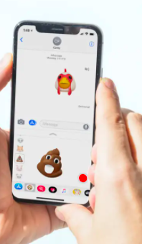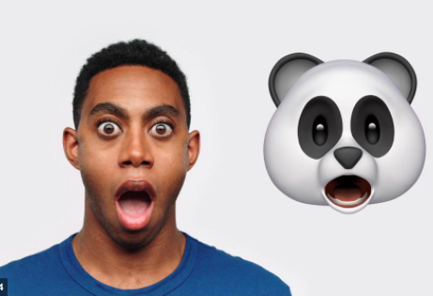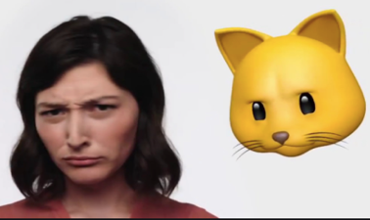

References and links:

<https://edgy.app/if-you-think-you-can-express-emotion-in-text-think-again>

<https://josephmalloch.wordpress.com/portfolio/expressive-keyboards/>

<https://www.thesun.co.uk/tech/4828993/what-are-iphone-x-animojis-your-guide-to-the-new-emojis-which-use-face-id-to-mimic-your-facial-movements/>

<https://www.usatoday.com/story/tech/2019/09/24/tool-tell-you-if-your-text-comes-across-too-harshly/2411158001/>